Quantum-Enhanced Neural Networks: A Controlled Benchmark of Hybrid Variational Quantum Circuits Against Classical Baselines Under Simulated NISQ Noise
Madhav Joshi¹
¹Department of CSE in Artificial Intelligence & Machine Learning
Marwadi University, Rajkot, Gujarat, India
madhav.joshi132389@marwadiuniversity.ac.in
Abstract—Hybrid quantum-classical neural networks built on variational quantum circuits (VQCs) are a leading approach to machine learning on near-term quantum devices, yet reported advantages often rest on weak baselines, mismatched model sizes, or noiseless simulation. This paper presents a controlled benchmark of a Quantum-Enhanced Neural Network (QENN) that places a VQC between classical input and output layers. Two design questions are examined: whether trainable data encoding improves on fixed angle encoding, and whether noise-aware training improves robustness under simulated NISQ noise. QENN variants are compared with logistic regression, a support vector machine, and parameter-matched multilayer perceptrons on four binary classification tasks, using stratified five-fold cross-validation over five random seeds. Models are evaluated by accuracy, F1-score, AUC-ROC, training cost, gradient variance, and accuracy loss under depolarising noise. [Insert main result after experiments: best QENN variant versus best classical baseline, with mean ± std, and the main finding on encoding and noise-aware training.] The study does not claim quantum advantage; it identifies the conditions under which a hybrid VQC is competitive with, or falls short of, well-tuned classical models, and releases all code and configurations for reproduction.
Index Terms—Quantum Machine Learning, Variational Quantum Circuits, Hybrid Quantum-Classical Neural Networks, NISQ Devices, Data Encoding, Noise-Aware Training, Benchmarking, Qiskit, PennyLane.
I. Introduction
Modern deep learning demands rapidly growing computational resources, which has renewed interest in alternative computing paradigms. A quantum computer stores information in the amplitudes of an n-qubit state whose Hilbert space has dimension 2^{n}, and it exploits superposition, entanglement, and interference. Present devices, however, are small and noisy—the Noisy Intermediate-Scale Quantum (NISQ) regime [1], [2]—so practical quantum machine learning (QML) [3] is largely limited to hybrid methods in which a short parameterised circuit is trained by a classical optimiser. A large state space is not, by itself, evidence of a learning advantage.
Variational quantum circuits (VQCs), also called parameterised quantum circuits, are the most widely studied building block of such hybrid models [4], [5]. A classical input is encoded into a quantum state, transformed by trainable rotations and entangling gates, and read out as expectation values that feed a classical layer. Circuit gradients can be obtained on hardware with the parameter-shift rule [6], [7]. Three issues dominate the practical picture: vanishing gradients (barren plateaus) as circuits grow [8], the strong dependence of model expressivity on the data-encoding scheme [9], [10], and hardware noise [2].
Claims of quantum benefit are also difficult to verify. A recent large-scale benchmarking study reported that, on the small datasets it examined, simple classical models generally outperformed the quantum classifiers tested [11], and related work shows that access to data can allow classical learners to rival quantum models [12]. Credible evidence therefore needs matched model sizes, tuned classical baselines, repeated runs, and explicit noise modelling.
This paper addresses that need with a Quantum-Enhanced Neural Network (QENN): a VQC sandwiched between classical input and output layers (Fig. 1). Four research questions guide the study. RQ1: How does QENN compare with parameter-matched classical models on small classification tasks? RQ2: Does trainable data encoding outperform fixed encoding? RQ3: How do qubit count and circuit depth affect accuracy and trainability? RQ4: Does noise-aware training improve robustness under simulated NISQ noise? The study makes three contributions: (1) an open-source hybrid QENN implementation with fixed and trainable encoding; (2) a protocol-controlled comparison against classical baselines; and (3) an evaluation of depth, width, and simulated-noise robustness. We do not claim quantum advantage; the aim is to map where a hybrid VQC is competitive and where it is not. [Keep only the contributions you actually complete.]
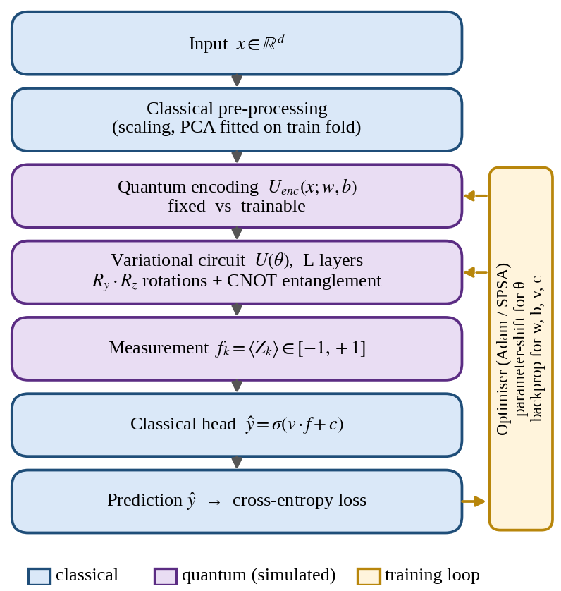
Fig. 1. QENN hybrid architecture. Classical layers (blue) surround a simulated quantum block (purple); a classical optimiser updates both quantum and classical parameters.
II. Related Work
Havlíček et al. [13] mapped data into a quantum feature space and demonstrated a variational classifier and a kernel method on a superconducting processor, though on synthetic data. Schuld et al. [14] proposed circuit-centric classifiers built from low-depth trainable circuits, and Cong et al. [15] introduced quantum convolutional architectures whose parameter count grows only logarithmically with the number of qubits.
Pérez-Salinas et al. [10] showed that re-uploading the input at several points in a circuit allows even a single-qubit model to act as a universal classifier, and Schuld et al. [9] showed that the functions a model can represent are governed by its encoding. Abbas et al. [16] argued, using effective dimension, that suitably designed quantum neural networks can offer higher capacity and faster training; this result is specific to the models and datasets they studied. These findings motivate the trainable-encoding variant used here.
On trainability, McClean et al. [8] showed that gradient variance can vanish exponentially with qubit number for sufficiently random circuits. Hardware error is commonly handled by mitigation techniques such as zero-noise extrapolation [17]; training with injected noise, as studied here, is a lighter alternative that adds no extra circuit executions at inference.
TABLE I
Representative Prior Work and Its Limitation for This Study
Work | Focus | Limitation here
Havlíček [13] | Quantum feature maps; hardware demo | Synthetic data; limited classical comparison
Pérez-Salinas [10] | Data re-uploading | Small tasks; noise not central
McClean [8] | Barren plateaus | Random-circuit theory; no end-to-end accuracy study
Bowles [11] | Benchmarking QML models | Noise-aware training not examined

Prior work usually examines encoding, trainability, noise, or baseline strength in isolation. This study evaluates them under one fixed protocol on shared tasks and seeds. This is a gap in our chosen experimental scope, not a claim that no related study exists.
III. Methodology
A. Problem Formulation
Let D = {(x_{i}, y_{i})} for i = 1,…,N, with x_{i} ∈ R^{d} and y_{i} ∈ {0, 1}. A QENN is a function ŷ = h(x; Θ) with Θ = (θ, w, b, v, c): θ are circuit parameters, (w, b) are encoding parameters (frozen in the fixed variant), and (v, c) define the classical output layer. The task is to minimise the binary cross-entropy of Eq. (5) on training data and to maximise generalisation on held-out folds.
B. Encoding and Variational Circuit
After pre-processing, each of the n = d features is scaled to [0, π] and assigned to one qubit. The input state is
|ψ(x)⟩ = U_{enc}(x) |0⟩^{⊗n} (1)
In the fixed variant, U_{enc}(x) applies R_{y}(x_{i}) to qubit i. In the trainable variant, it applies R_{y}(w_{i}x_{i} + b_{i}) with learned (w, b), and the encoding is repeated before every layer (data re-uploading [10]). The variational circuit applies L layers of R_{y} and R_{z} rotations followed by an entangling pattern W_{ent} (none, linear, circular, or all-to-all), with layer 1 applied first:
U(θ) = ∏_{l=1}^{L} [ W_{ent} · ⊗_{i=1}^{n} R_{z}(θ_{l,i,2}) R_{y}(θ_{l,i,1}) ] (2)
which has 2nL trainable circuit parameters (Fig. 2). The outputs are Pauli-Z expectation values, fed to a sigmoid output layer and trained with cross-entropy:
f_{k}(x; θ) = ⟨ψ(x)| U†(θ) Z_{k} U(θ) |ψ(x)⟩ ∈ [−1, +1] (3)
ŷ = σ(v · f + c) (4)
J(Θ) = −(1/N) Σ_{i} [ y_{i} log ŷ_{i} + (1 − y_{i}) log(1 − ŷ_{i}) ] (5)
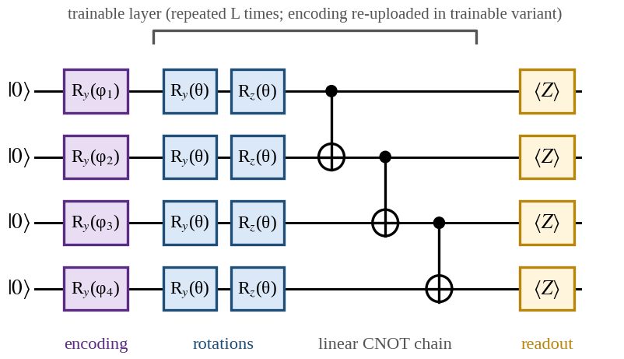
Fig. 2. One QENN circuit for n = 4 qubits with linear entanglement. The bracketed block is repeated L times.
C. Gradients and Optimisation
Circuit gradients use the parameter-shift rule, which is exact for these rotation gates and compatible with hardware:
∂f_{k}/∂θ_{j} = ½ [ f_{k}(θ + (π/2)e_{j}) − f_{k}(θ − (π/2)e_{j}) ] (6)
It needs two circuit evaluations per parameter per sample, i.e. 4nL per sample for the circuit. For speed, bulk simulator runs use backpropagation, and agreement with parameter-shift is verified on a subset. Classical parameters use backpropagation. The default optimiser is Adam [18]; SPSA [19] is evaluated as a hardware-friendly alternative.
D. Noise Model and Noise-Aware Training
Noise is simulated with a depolarising channel after every gate, E_{p}(ρ) = (1 − p)ρ + (p/3)(XρX + YρY + ZρZ) for single-qubit gates, with an analogous two-qubit channel after CNOT gates; measurements use finite shots. Bit-flip and phase-flip channels are secondary models. Noise-aware training injects noise at rate p_{train} during training, whereas the noise-unaware model is trained noiselessly. Both are tested over the full grid of p_{test}, so that train–test noise mismatch is visible.
E. Classical Baselines and Fairness
Baselines are logistic regression, an RBF-kernel SVM, and two multilayer perceptrons (MLPs): one whose trainable-parameter count is matched to the QENN, including its classical layers, and one tuned freely. All models share identical splits and pre-processing, and hyperparameters are tuned by inner-loop cross-validation with an equal search budget per model family. Parameter matching is imperfect because quantum and classical parameters are not equivalent, so accuracy is also reported against wall-clock time and circuit executions.
F. Hypotheses
Hypotheses are fixed before running experiments. H1: A parameter-matched MLP will match or exceed QENN accuracy on all four tasks. H2: Trainable encoding will improve QENN accuracy over fixed encoding on the non-linearly separable tasks. H3: Beyond a moderate depth, extra layers will raise cost and reduce gradient variance without improving accuracy. H4: Noise-aware training will recover part of the accuracy lost under depolarising noise. The results may support or reject each of these.
IV. Experimental Setup
A. Datasets
Four binary tasks are used: Two Moons and Concentric Circles (synthetic, 1,000 samples each, generated with scikit-learn [20]); Breast Cancer Wisconsin (569 samples, 30 features) [21]; and Iris restricted to versicolor versus virginica (100 samples, 4 features) [22]. Where d exceeds the qubit count, PCA reduces features to n components, fitted on the training fold only, followed by min–max scaling to [0, π].
B. Configuration
Table II lists the starting configuration. Main results use n = 4 and L = 3 (24 circuit parameters); ablations vary one factor at a time. Any value changed after tuning will be reported.
TABLE II
Starting Experimental Configuration
Parameter | Value
Qubits n | 4 (ablation: 2, 4, 6, 8)
Depth L | 3 (ablation: 1, 2, 3, 4, 6)
Entanglement | Linear (ablation: none, circular, all-to-all)
Encoding | Fixed vs trainable (re-uploading)
Optimiser | Adam, lr 0.01; SPSA as alternative
Training | Batch 32; ≤100 epochs; early stopping (patience 10)
Noise p | 0, 0.001, 0.005, 0.01, 0.02 (depolarising)
Shots | Analytic (noiseless); 1,024 (noisy)
Validation | Stratified 5-fold CV × 5 seeds = 25 runs

C. Protocol and Metrics
Every configuration is run with stratified five-fold cross-validation and five seeds. Metrics are accuracy, precision, recall, F1-score, and AUC-ROC; training cost (wall-clock time and circuit executions); noise robustness, Δacc(p) = acc(0) − acc(p); and trainability, the variance of ∂J/∂θ_{j} over 100 random initialisations as a function of n and L. Results are reported as mean ± standard deviation with 95% bootstrap confidence intervals. Paired Wilcoxon signed-rank tests serve only as supporting evidence because cross-validation folds overlap. Raw per-run outputs are stored in CSV, and all tables and figures are generated from that file without manual edits.
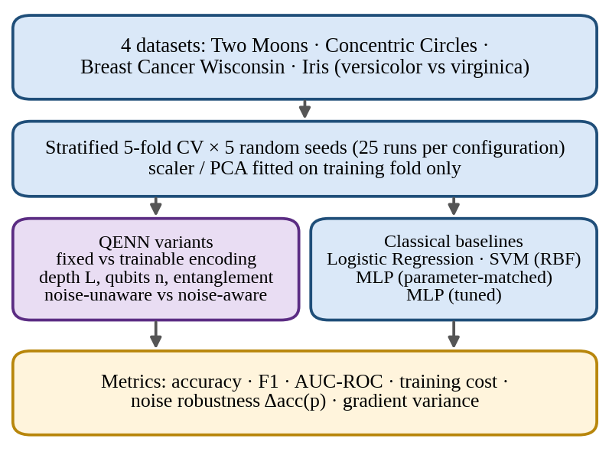
Fig. 3. Experimental protocol: shared datasets, splits, and seeds feed both QENN variants and classical baselines.
D. Implementation
Experiments use Python with PyTorch [23], PennyLane [24], and Qiskit with Qiskit Aer [25] for noisy simulation, plus scikit-learn [20]. Hardware: [insert CPU/GPU/RAM]. Library versions: [insert exact versions]. No real quantum hardware is used in this study.
V. Results and Analysis
[DRAFT NOTE: every result cell below is intentionally empty. Fill them only from the raw experiment CSV, then delete this note.]
A. Overall Performance
Table III compares all models across the four tasks. [Insert 2–3 sentences: best model per task, whether differences exceed the confidence intervals, and whether H1 is supported.]
TABLE III
Test Accuracy (%), Mean ± Std over 25 Runs
Model | Params | Moons | Circles | Cancer | Iris
Log. Reg. | — | — | — | — | —
SVM (RBF) | — | — | — | — | —
MLP (matched) | — | — | — | — | —
MLP (tuned) | — | — | — | — | —
QENN-fixed | — | — | — | — | —
QENN-trainable | — | — | — | — | —

B. Encoding and Architecture Ablation
[Insert Fig. 4: accuracy versus depth L for fixed and trainable encoding, and Fig. 5: gradient variance versus n and L. State whether H2 and H3 are supported, and which entanglement pattern performed best.]
C. Noise Robustness
Table IV reports accuracy under depolarising noise. [Insert analysis: size of the accuracy drop, whether noise-aware training recovers part of it, behaviour at mismatched p, and whether H4 is supported.]
TABLE IV
Test Accuracy (%) vs Noise Level p — [dataset]
Model | p = 0 | 0.005 | 0.01 | 0.02
QENN, noise-unaware | — | — | — | —
QENN, noise-aware | — | — | — | —
Best classical (reference) | — | n/a | n/a | n/a

D. Computational Cost
Because classical simulation cost grows as 2^{n}, simulated wall-clock time must not be read as a prediction of hardware runtime. [Insert training time and circuit-execution counts per model, and accuracy per trainable parameter.]
VI. Limitations
This study has clear limits. (i) All quantum results come from classical simulation; real devices add crosstalk, drift, and readout error that a depolarising model does not capture. (ii) Simulation restricts n to a few qubits, and small PCA-reduced datasets may hide differences that appear at scale. (iii) Parameter counts are an imperfect basis for matching quantum and classical models. (iv) Hyperparameter budgets are finite, so a stronger configuration of any model may exist. (v) The study tests accuracy and trainability, not complexity-theoretic advantage: a result favouring QENN would not establish quantum advantage, and a result against it would not rule out advantage on other tasks or at larger scale. (vi) Noise-aware training is assessed only against the noise channels simulated here.
VII. Conclusions
This paper presented a controlled benchmark of a hybrid Quantum-Enhanced Neural Network, comparing fixed and trainable encoding and noise-unaware and noise-aware training against matched and tuned classical baselines. [After the experiments, answer RQ1–RQ4 directly with key numbers and state which of H1–H4 were supported.] The protocol—matched baselines, repeated cross-validation, explicit noise modelling, and released code—is intended to make any conclusion, favourable or not, reproducible.
Future work includes running the best configurations on IBM Quantum hardware, adding error mitigation such as zero-noise extrapolation [17], evaluating quantum kernels and convolutional circuits [15], testing larger and image-based datasets, and comparing against quantum-inspired classical models.
References
[1] J. Preskill, "Quantum computing in the NISQ era and beyond," Quantum, vol. 2, p. 79, 2018.
[2] K. Bharti et al., "Noisy intermediate-scale quantum algorithms," Rev. Mod. Phys., vol. 94, 015004, 2022.
[3] J. Biamonte et al., "Quantum machine learning," Nature, vol. 549, pp. 195–202, 2017.
[4] M. Benedetti et al., "Parameterized quantum circuits as machine learning models," Quantum Sci. Technol., vol. 4, 043001, 2019.
[5] M. Cerezo et al., "Variational quantum algorithms," Nat. Rev. Phys., vol. 3, pp. 625–644, 2021.
[6] K. Mitarai et al., "Quantum circuit learning," Phys. Rev. A, vol. 98, 032309, 2018.
[7] M. Schuld et al., "Evaluating analytic gradients on quantum hardware," Phys. Rev. A, vol. 99, 032331, 2019.
[8] J. R. McClean et al., "Barren plateaus in quantum neural network training landscapes," Nat. Commun., vol. 9, 4812, 2018.
[9] M. Schuld, R. Sweke, and J. J. Meyer, "Effect of data encoding on the expressive power of variational quantum-machine-learning models," Phys. Rev. A, vol. 103, 032430, 2021.
[10] A. Pérez-Salinas et al., "Data re-uploading for a universal quantum classifier," Quantum, vol. 4, p. 226, 2020.
[11] J. Bowles, S. Ahmed, and M. Schuld, "Better than classical? The subtle art of benchmarking quantum machine learning models," arXiv:2403.07059, 2024.
[12] H.-Y. Huang et al., "Power of data in quantum machine learning," Nat. Commun., vol. 12, 2631, 2021.
[13] V. Havlíček et al., "Supervised learning with quantum-enhanced feature spaces," Nature, vol. 567, pp. 209–212, 2019.
[14] M. Schuld et al., "Circuit-centric quantum classifiers," Phys. Rev. A, vol. 101, 032308, 2020.
[15] I. Cong, S. Choi, and M. D. Lukin, "Quantum convolutional neural networks," Nat. Phys., vol. 15, pp. 1273–1278, 2019.
[16] A. Abbas et al., "The power of quantum neural networks," Nat. Comput. Sci., vol. 1, pp. 403–409, 2021.
[17] K. Temme, S. Bravyi, and J. M. Gambetta, "Error mitigation for short-depth quantum circuits," Phys. Rev. Lett., vol. 119, 180509, 2017.
[18] D. P. Kingma and J. Ba, "Adam: A method for stochastic optimization," ICLR, 2015.
[19] J. C. Spall, "Multivariate stochastic approximation using a simultaneous perturbation gradient approximation," IEEE Trans. Autom. Control, vol. 37, no. 3, pp. 332–341, 1992.
[20] F. Pedregosa et al., "Scikit-learn: Machine learning in Python," J. Mach. Learn. Res., vol. 12, pp. 2825–2830, 2011.
[21] W. N. Street, W. H. Wolberg, and O. L. Mangasarian, "Nuclear feature extraction for breast tumor diagnosis," Proc. SPIE, vol. 1905, pp. 861–870, 1993.
[22] R. A. Fisher, "The use of multiple measurements in taxonomic problems," Ann. Eugenics, vol. 7, no. 2, pp. 179–188, 1936.
[23] A. Paszke et al., "PyTorch: An imperative style, high-performance deep learning library," NeurIPS, 2019.
[24] V. Bergholm et al., "PennyLane: Automatic differentiation of hybrid quantum-classical computations," arXiv:1811.04968, 2018.
[25] Qiskit contributors, "Qiskit: An open-source framework for quantum computing," Zenodo, 2023.

